24.To design DFA trasition diagram starting with a’s or b’s in automata.

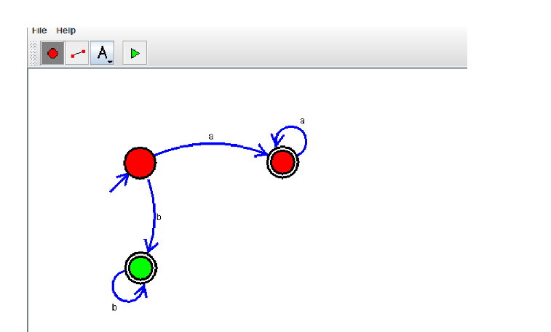

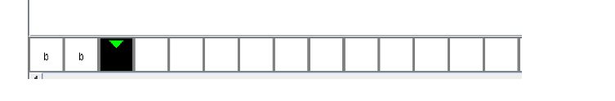

**Result:** Thus designing DFA which starts with a’s or b’s is done and verified by giving sample inputs.